Grade 7 Accelerated · Unit 3 · Thread A · Day 1  Exponent Laws with Variable Bases  Question Bank 3.T1 ANSWER KEY | Name  Date  Period

Show your work. Circle your final answer.
For questions 1 through 6, write an equivalent expression as a single monomial. Assume no variable equals 0.
1. 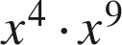
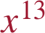

2. 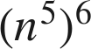


3. 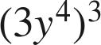
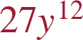
The 3 is cubed as well.

4. 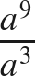


5. 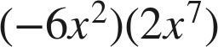


6. 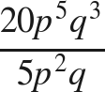
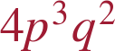
Coefficients divide; each variable's exponents subtract.

For questions 7 and 8, apply more than one law. Write each answer as a single monomial.
7. Write an equivalent expression.
a. 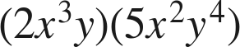
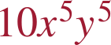
b. 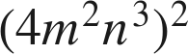

c. 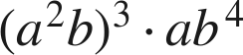

a⁶b³ · ab⁴.

8. Write an equivalent expression.
a. 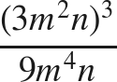

27m⁶n³ over 9m⁴n.
b. 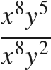
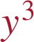
x⁰ = 1.
c. 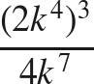

8k¹² over 4k⁷.

Working backwards.
9. Find the value of that makes each statement true.
a. 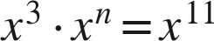
n = 8
b. 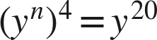
n = 5
c. 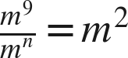
n = 7
9 − n = 2.

10. A rectangle has length 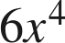 and width 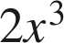.
a. Write its area as a single monomial.

length × width; coefficients multiply, exponents add.
b. A square has side length 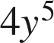. Write its area as a single monomial.

(4y⁵)² — the 4 is squared too.

11. Which expression is equivalent to 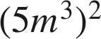 ?
○ A. 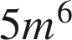
○ B. 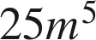
○ C. 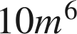
● D. 
D

12. Select ALL of the expressions that are equivalent to 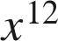.
☒ A. 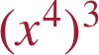
☐ B. 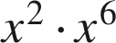
☒ C. 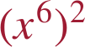
☒ D. 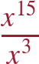
☐ E. 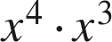
☒ F. 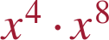
A, C, D and F

